**Synopsis**

**On**

**Online Quiz System**

**by**

Vinay Kumar (2000290140132)

Rahul Dadoo (2000290140093)

Omveer Singh (2000290140082)

**Session:2021-2022 (4th Semester)**

Under the supervision of

**Ms. Vidushi ( Assistant Professor )**

### KIET Group of Institutions, Delhi-NCR, Ghaziabad



### Department Of Computer Applications

**KIET GROUP OF INSTITUTIONS, DELHI-NCR, GHAZIABAD-201206**

(march- 2022)

**ABSTRACT**

The purpose of MCQ Quiz Application is to automate the existing manual system by the help of computerized equipment and full-fledged computer software, fulfilling their requirements, so that their valuable data/information can be stored for a longer period with easy accessing and manipulation of the same. The required software and hardware are easily available and easy to work with.

MCQ Quiz Application, as described above, can lead to error free, secure, reliable and fast management system. It can assist the user to concentrate on their other activities rather to concentrate on the record keeping. Thus it will help organization in better utilization of resources. The organization can maintain computerized records without redundant entries. That means that one need not be distracted by information that is not relevant, while being able to reach the information.

The aim is to automate its existing manual system by the help of computerized equipment and full-fledged computer software, fulfilling their requirements, so that their valuable data/information can be stored for a longer period with easy accessing and manipulation of the same. Basically the project describes how to manage for good performance and better services for the clients.

**TABLE OF CONTENTS**

1. Introduction 2
2. Literature Review 3
3. Project / Research Objective 4
4. Research Methodology 5
5. Project / Research Outcome 6
6. Proposed Time Duration 7

References 8

**INTRODUCTION**

Online Examination System refers to service as conduct online examination or test. It will use for student progress evaluation using modern computer technology. It replaced the paperwork and overcome the outcomes of traditional way of examinations using paper or pen. It is web based platform can be used by Admin at any remote location. Online Examination System is fully developed automated system is to efficiently evaluate the candidate progress that not only save the time of Examination Controller and also gives fast result. The Administrator of the system has authority to propose tests or papers. It is cost effective and time effective. The candidate can login through proposed computer with their Enrolment number matching the details to the student’s database, Then they can take the exam. Candidate can give their course’s examination in a specific duration and in specific number of questions. The questions can be appear in both mode MCQ (Multiple Choice Questions) and answer in paragraph.

**2. Literature Review**

Xue (2006), adapted the online examination system using a mode known as "B/W Mode". Web server

was used to control the tests and provide information to students. The main goal of the study is to reduce

the use of paper and develop a test system that is safe to use. Among the features utilized was only allow

the system to be used after receiving the application from student to use it.

Ria Mae H (2013), studied about an online examination system that can be administered manually or

automatically by lecturers. Lecturers can send questions via the web and students will answer and send

their answers online via the Internet. By using this online examination system, grading process can be

done automatically. Researcher has conducted a survey about the form and type of examination questions

that will be included in the online examination system

Xue (2006), adapted the online examination system using a mode known as "B/W Mode". Web server was used to control the tests and provide information to students. The main goal of the study is to reduce the use of paper and develop a test system that is safe to use. Among the features utilized was only allow the system to be used after receiving the application from student to use it.

Ria Mae H (2013), studied about an online examination system that can be administered manually or automatically by lecturers. Lecturers can send questions via the web and students will answer and send their answers online via the Internet. By using this online examination system, grading process can be done automatically. Researcher has conducted a survey about the form and type of examination questions that will be included in the online examination system.

**3-Project Objective**

The main objective of the Project on MCQ Quiz Application is to manage the details of Students, Examinations, Marks, Courses, Papers. It manages all the information about Students, Results, Papers, Students. The project is totally built at administrative end and thus only the administrator is guaranteed the access. The purpose of the project is to build an application program to reduce the manual work for managing the Students, Examinations, Results, Marks. It tracks all the details about the Marks, Courses, Papers.

**Functionalities provided by MCQ Quiz Application are as follows:**

Provides the searching facilities based on various factors. Such as Students, Marks, Courses, Papers

MCQ Quiz Application also manage the Results details online for Courses details, Papers details, Students.

It tracks all the information of Examinations, Results, Courses ect

Manage the information of Examinations

Shows the information and description of the Students, Marks

To increase efficiency of managing the Students, Examinations

**4- Reaserch Methodlogy**

The research design depends on the purpose of the study (Maxwell, 2005). This study uses a quantitative approach carried out using a survey method. The survey method is appropriate for the management of the study because the reviews to be conducted will focus on the usability online testing system and based on the questions submitted. In addition, it involves data collection and information from the respondent involved only

.

**5 Project Outcomes**

Online Quiz system is a application software and website have done work in two part first is User and second is Admin .

**User:-**

* **Registration**
* **Login**
* **Take quiz**
* **Show performance**

**Admin-**

Second is Admin here admin can create the quiz and manage the settings of quiz like time duration and number of questions and also see the performance of user.

**6 -Proposed Time Duration**

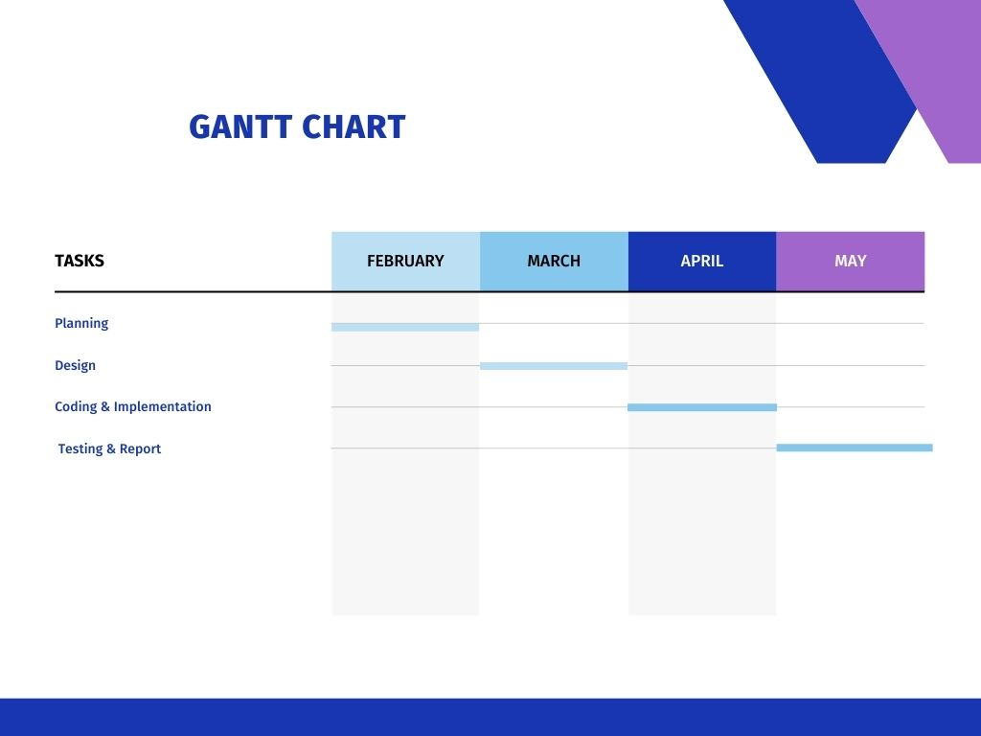

**7- References**

**Internet References:**

1  <http://blog.jitbit.com/2007/08/why-we-still-use-vb6-for-some-projects.html>

  <http://homepages.uel.ac.uk/D.Bowden/>

  <http://dev.mysql.com/doc/refman/5.0/en/connector-odbc-general-information.html>

  [http://www.cs.virginia.edu/~horton/cs494/info/rose-howto-v2.pd](http://www.cs.virginia.edu/~horton/cs494/info/rose-howto-v2.pdf)